Exercise 1: Mocking and Stubbing
This document covers the steps I followed to complete this exercise, where the goal was to test a service that depends on an external API by using Mockito to mock that API and stub its methods, instead of relying on a real external call.

What I Did
I created a new Maven project called Mockito exercises and added the Mockito and JUnit 5 dependencies to pom.xml. Since this project uses JUnit 5 (Jupiter) instead of JUnit 4, I made sure to import org.junit.jupiter.api.Test and org.junit.jupiter.api.Assertions.assertEquals rather than the JUnit 4 versions used in the earlier exercises.
The dependencies I added to pom.xml:
<dependencies>
<dependency>
<groupId>org.mockito</groupId>
<artifactId>mockito-core</artifactId>
<version>5.11.0</version>
<scope>test</scope>
</dependency>
<dependency>
<groupId>org.junit.jupiter</groupId>
<artifactId>junit-jupiter</artifactId>
<version>5.10.2</version>
<scope>test</scope>
</dependency>
</dependencies>

Next, I created an ExternalApi interface to represent the external dependency, with a single getData() method. I then created a MyService class that depends on ExternalApi and simply delegates to it through a fetchData() method.
ExternalApi.java:
package org.example;

public interface ExternalApi {
String getData();
}

MyService.java:
package org.example;

public class MyService {
private final ExternalApi api;

public MyService(ExternalApi api) {
this.api = api;
}

public String fetchData() {
return api.getData();
}
}

Finally, in the test class, I used Mockito.mock() to create a fake version of ExternalApi, then used when(...).thenReturn(...) to stub the getData() method so it always returns "Mock Data" instead of calling a real API. I passed this mock into MyService and verified that fetchData() correctly returned the stubbed value using assertEquals().

Test Code
The final MyServiceTest.java file looks like this:
package org.example;

import static org.mockito.Mockito.*;
import org.mockito.Mockito;
import static org.junit.jupiter.api.Assertions.assertEquals;
import org.junit.jupiter.api.Test;

public class MyServiceTest {

@Test
public void testExternalApi() {
ExternalApi mockApi = Mockito.mock(ExternalApi.class);
when(mockApi.getData()).thenReturn("Mock Data");

MyService service = new MyService(mockApi);
String result = service.fetchData();

assertEquals("Mock Data", result);
}
}

Running the Test
I ran testExternalApi() from IntelliJ IDEA, and the Run panel confirmed the mock and stub worked as expected:
- testExternalApi() shows a green checkmark
- The summary reads "1 test passed"
- The process finished with exit code 0
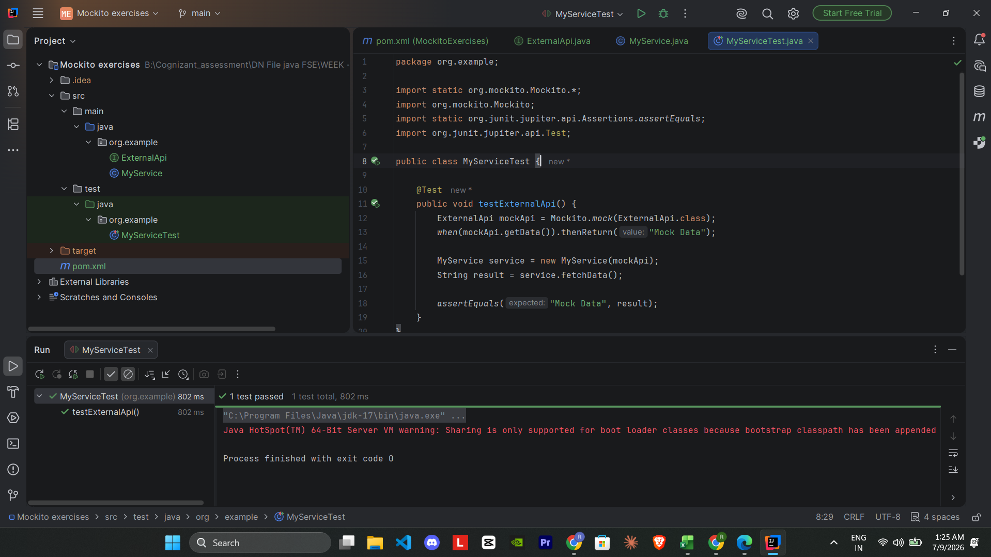

Result
The test passed successfully, confirming that MyService correctly used the mocked ExternalApi and returned the stubbed "Mock Data" value without ever calling a real external service. This demonstrates mocking and stubbing with Mockito working correctly, and completes this exercise successfully.

